- Answer each question in the space provided (use separate paper for scratch work).
- All relevant work must be shown for full credit.
- Copying work from another source is plagiarism and carries serious penalties.
- Calculators are permitted, but no notes, text, or laptops. Cell phones should be muted and left in your pocket or bag.
Word Problems:
- Mark each of the following statements as either descriptive (D) or inferential (I). [3]
(a) 4 out of 5 dentists prefer our brand of toothpaste. _Inf._
(b) 5% of the leaves we measured are longer than 15cm. _Des._
(c) 1 in 11 men in Canada will get lung disease at some time in their lives. _Inf._
(d) The probability of a male age 16-20 getting in a car collision is 1.5%. _Inf._
(e) 0.9% of female drivers in ICBC’s 2003 study were involved in a
car collision _Des._
- Mark each of the following variables as nominal (N), ordinal (O), discrete (D), or continuous (C):
(a) The breaking strength of a given type of string _Con_
(b) The length of time a customer is put on hold _Con_
(c) The whole number of minutes a customer is put on hold _Dis_
(d) The political party a voter votes for _Nom_
(e) The final letter grade for a course at TWU _Ord_
(f) A person’s favorite color _Nom_
- Assume the table below represents the raw data for an experiment measuring the height of trees. Draw a frequency histogram for the height of the trees, classifying the data by tens of metres (e.g., 0-10m, 10-20m, 20-30m, etc.).
6m | 7m | 7.5m | 9m | 11m
11m | 12m | 16m | 22m | 24m
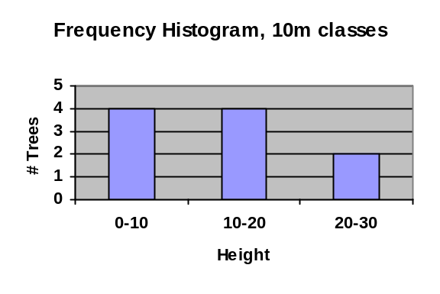
- Using the same data from the previous problem, draw a relative frequency histogram, using the same classes.
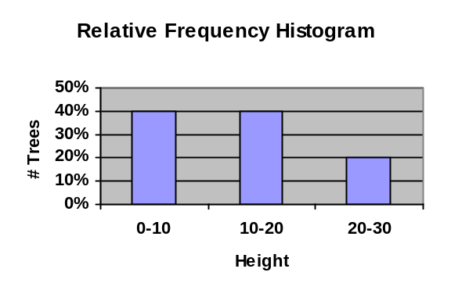
- Using the same data from the previous problem, draw a frequency histogram, classifying the data in groups of 5m.
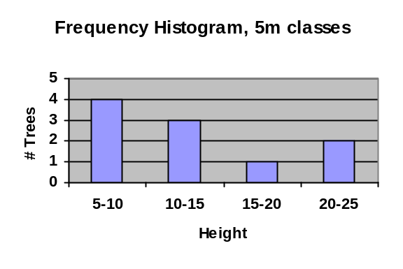
- Using the same data from the previous problem, give the
(a) mean 12.6
(b) median 11
(c) mode 11
(d) first quartile (1/4) 7.5 (3rd entry)
(e) third quartile (3/4) 16 (8th entry)
(f) mean absolute deviation (MAD) 4.87
(g) sample variance 38.8
(h) sample standard deviation 6.23
- Using the same data from the previous problem, draw a box-and-whiskers plot.
6
12
18
24
- Using the same data from the previous problem, according to Chebyshev’s theorem, at most what fraction of the population lies further than 2 standard deviations away from the mean?
One quarter.
- A bag contains 4 red marbles, 5 green marbles, and one yellow marble.
(a) One marble is drawn from the bag. List the sample space.
{ R, G, Y }
(b) Now assume instead that two marbles are drawn from the bag, without replacement. Draw a tree diagram representing the sample space (list only outcomes that can actually occur).
(c) Annotate your tree diagram with probabilities for each branch of the tree and for each final outcome.
(d) What are the odds of choosing two red marbles?
Probability of (R,R) is 2/15 = 2/(2+13): odds are “2 to 13”.
Can also express as “12 to 78” or any other multiple.
R: 4/10
G: 5/10
Y: 1/10
R: 3/9
G: 5/9
Y: 1/9
G: 4/9
R: 4/9
Y: 1/9
R:4/9
G: 5/9
(R, R): 12/90 = 2/15
(R, G): 20/90 = 2/9
(R, Y): 4/90 = 2/45
(G, R): 20/90 = 2/9
(G, G): 20/90 = 2/9
(G, Y): 5/90 = 1/18
(Y, R): 4/90 = 2/45
(Y, G): 5/90 = 1/18
- Describe an example of two events that are mutually exclusive. Be sure to describe the complete sample space as well.
A simple example is gender: the sample space is { M, F }, and the two events “gender is male” and “gender is female” are mutually exclusive.
- Consider the (fictional) data in the table below.
Province | BC | AB | SK
Likes Pineapple | 1.2 million | 0.8 million | 0.2 million
Doesn’t Like  Pineapple | 1.8 million | 1.2 million | 0.3 million
(a) Is affinity for pineapples independent of province? Yes
(b) What is the probability of a person in the study being from AB? 2/5.5 ~= 36%
(c) What is the probability of a person in the study liking pineapple? 2.2/5.5 = 40%
(d) What is the probability of a person in the study to be both from AB and a fan of pineapple? 0.8/5.5 ~= 14.5%
- Let A represent families with at least two kids. Let B represent families with at least two pets. Draw a separate Venn diagram shading in each region described:
(a) 60% of all families have at least two kids.
(b) 10% of all families have at least two kids and at least two pets.
(c) 70% of all families have either two kids or two pets.
(d) Given the above probabilities, what percentage of families have at least two pets? 70%-60%+10% = 20%
(e) What is the probability of a family having neither two kids nor two pets?
100%-70%=30%
(f) What is the probability of a family having at least two kids, given that they have at least two pets? 10/20 = 50%
2 Pets
2 Kids
2 Kids
2 Pets
2 Kids
2 Pets

